# JS Advanced Exam-Retake

# Problem 1. Gem Collection

**Environment Specifics**

Please be aware that every JS environment may **behave differently** when executing code. Certain things that work in the browser are not supported in **Node.js**, which is the environment used by **Judge**.

The following actions are **NOT** supported:

* **.forEach()** with **NodeList** (returned by **querySelector()** and **querySelectorAll()**)
* **.forEach()** with **HTMLCollection** (returned by **getElementsByClassName()** and **element.children**)
* Using the **spread-operator** (**...**) to convert a **NodeList** into an array
* **append()** in Judge (use only **appendChild()**)
* **prepend()**
* **replaceWith()**
* **replaceAll()**
* **closest()**
* **replaceChildren()**
* Always turn the collection into a **JS array** (forEach, forOf, et.)

If you want to perform these operations, you may use **Array.from()** to first convert the collection into an array.

**Use the provided skeleton to solve this problem.**

**Write the missing functionality** of this user interface. The functionality is divided in the following steps:

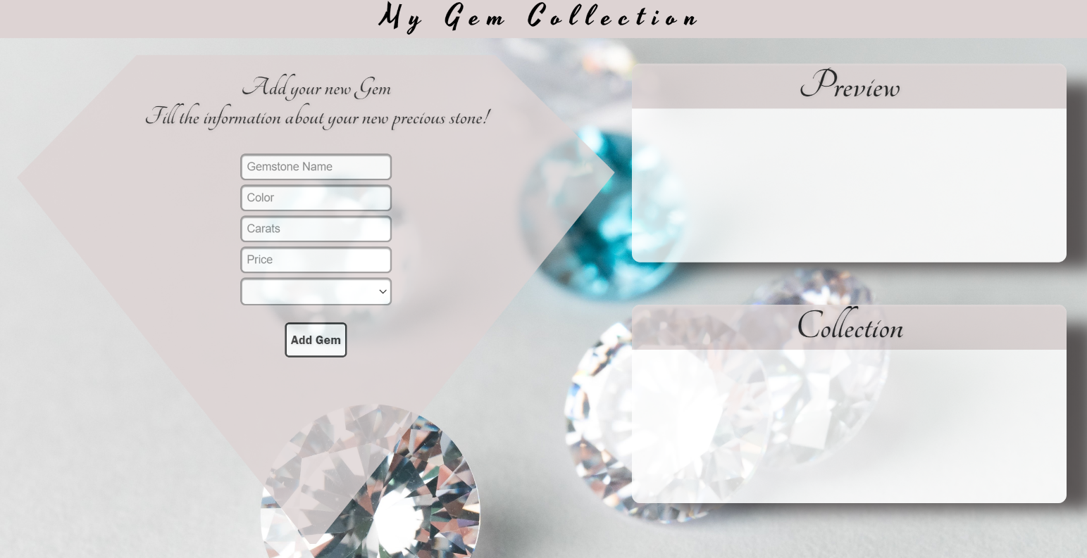**Your Task**

**Write the missing JavaScript code** to make the **Gem Collection** work as expected:

All fields **(Gemstone Name, Color, Carats, Price,** and **Type)** are **filled with the correct input**

* **Gemstone Name, Color, Age, Carats, Price** and **Type** are **non**-**empty** **strings**. If any of them is empty, the program should not do anything.

1. **Getting the information from the form**

## 

* On clicking the [“Add Gem”] button the information from the input fields is listed in the **"**preview" section. To the unordered list with id **"preview-list"**, should be added a list item, containing the input information.
* The text format and order for each list item should be the same as in the picture below.
* When the button is clicked, the input fields must be cleared and the ["Add Gem"] button must be **disabled**. At the same time the "Save to Collection", "Edit Information" and the "Cancel" buttons must be **added**.

The HTML structure looks like this:

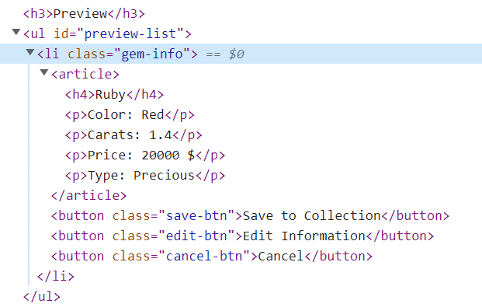

1. **Editing the information from the Preview**

**The functionality here is the following:**

* **When the "**Edit Information" **button is clicked, all of the information is loaded in the input fields from step 1 and all buttons in preview section are removed while the** ["Add Gem"] **button is enabled again.**

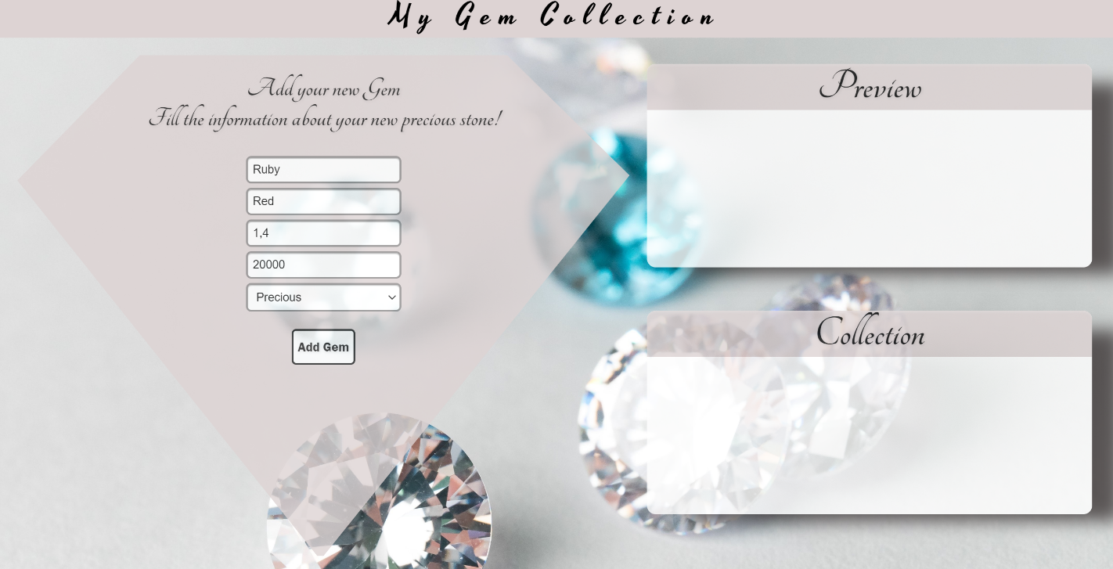

* **The list items must be removed from the** "preview-list" and **all of the information must go back to the input fields again**.

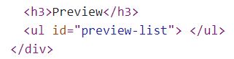

1. **Saving the information from the Preview**

* **When the** "Save to Collection" **button is clicked,** **the gem information must be transferred from "**preview" to **"**collection", for you that means a new list item should be added to the unordered list with id: **"collection"**, having the information about gems.

The HTML structure looks like this: 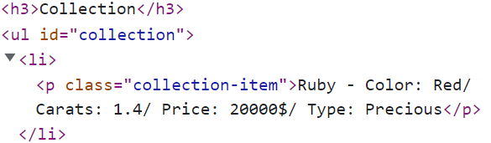

* **The list item from preview section must be removed while the** ["Add Gem"] **button is enabled again.**

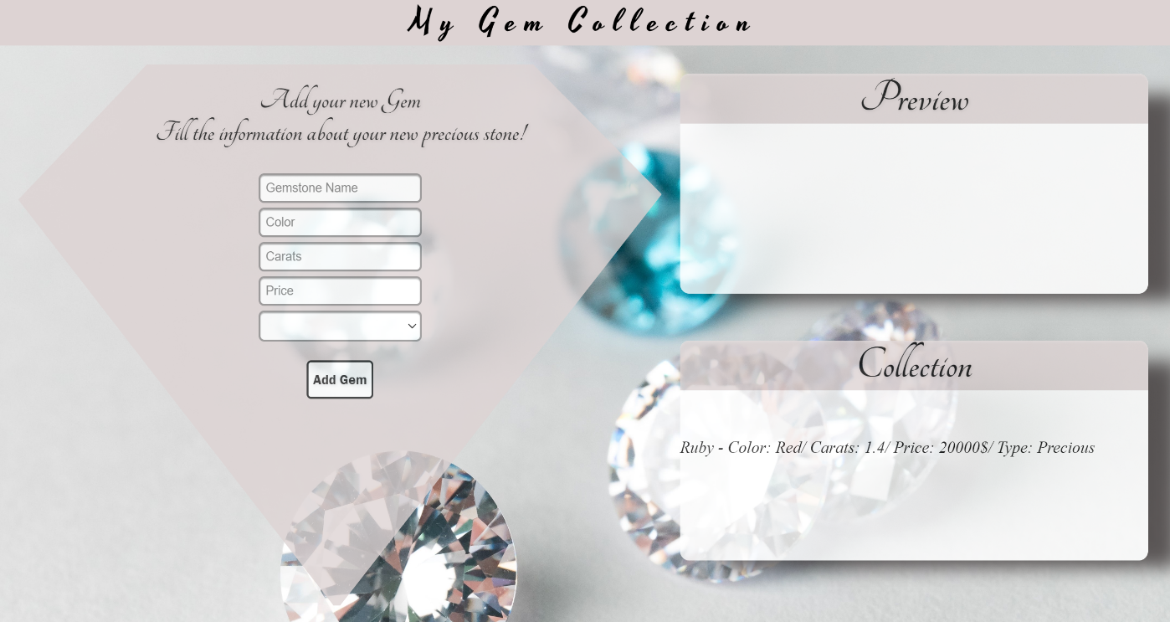

1. **Cancel the information from the Preview**

* **When the** "Cancel" **button is clicked,** **the list item must be removed from the** "preview-list" **and the** ["Add Gem"] **button is enabled again**.



# Submission

Submit only yours **solution()** function.

*GOOD LUCK… ☺*